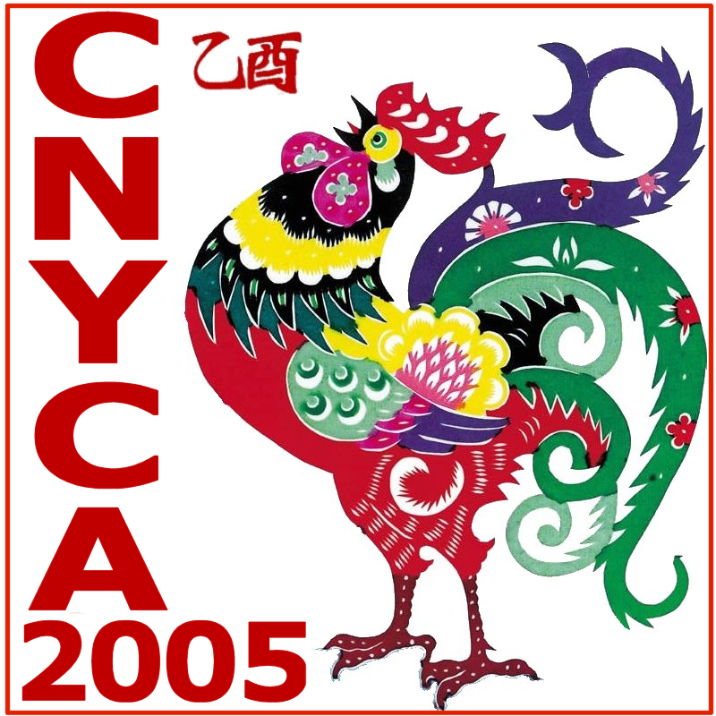
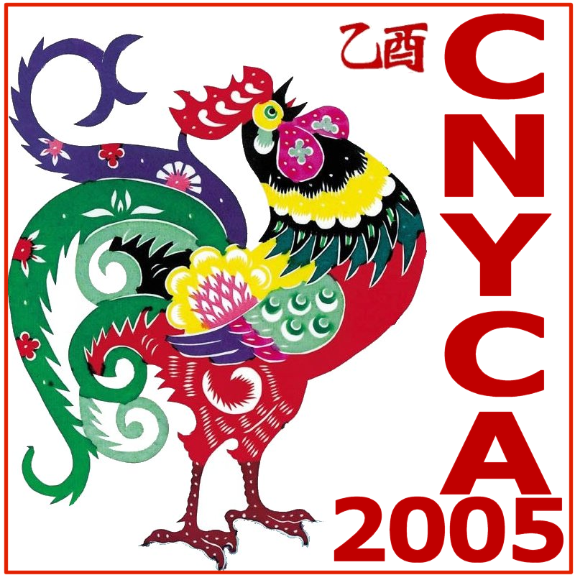

CHINESE NEW YEAR CELEBRATION

SPONSORSHIP FORM

Hosted By
CHINESE NEW YEAR CULTURE ASSOCIATION (CNYCA)
__ Diamond $ 2,000 Full-page ad. + 1 booth + Appreciation dinner (2) + Recognition plaque + Banner
__ Platinum $ 1,000 Full-page ad. + 1 booth + Appreciation dinner (2) + Recognition plaque
__ Gold $ 500 Full-page ad. + 1 booth + Program recognition
__ Silver $ 300 Full-page ad. + Program recognition

ADVERTISEMENT
__ Full page (7 in. x 10 in.) $ 200
__ Half page (7 in. x 5 in.) $ 100
__ Quarter page (3.5 in. x 5 in.) $ 50

VENDOR BOOTH
__ Vendor booth $ 100

SPONSOR RAFFLE PRIZE

Description | Quantity | Value
I, the undersigned, agree to
 be a sponsor of this event, as marked above (Please provide camera-ready ad.)
 advertise in the event program book, as marked above (Please provide camera ready ad.)
 sponsor a raffle prize as marked above.
Name of Organization: _______________________________________________________________
Authorized Signature/ Date: __________________________ Print Name: ______________________
Address: __________________________________________________________________________
Phone: __________________ Fax: _________________ Email:______________________________
Please send the completed form, sponsorship and camera-ready ad. to CNYCA-2005, P.O. Box 163690, Sacramento, CA 95816 by Friday, December 15, 2004. Camera-ready ad. may be emailed to mingtunglee@comcast.net
CNYCA Tax ID: 501(c)(3) 20-0834227
For more information about this Event, please visit our website at http://www.CNYCAsacramento.org
Or contact the following: Roy Chao (916) 392-8026, Tom Bhe (916) 355-4159

Rev. 1.0 – 8/31/2004

