Member Organizations:

Greater Sacramento Taiwanese Association CNYCA Chair
大沙加緬度臺灣同鄉會-本屆主席
Sacramento Mandarin School
CNYCA Vice-Chair
沙加緬度中文學校-本屆副主席
Asian Pacific Islander American Public Affairs Association
亞太裔公共事務聯盟
California Chinese Engineers Association
加州工程師協會
California Chinese e-Resources, Inc
加州華人資訊網
Chinese American Political Action Committee
美華參政會
Chinese Benevolent Association
二埠中華會館
Elk Grove Chinese Association
麋鹿林華人聯誼會
Elk Grove Chinese Association Foundation
麋鹿林華人聯誼會基金會
Great Wall Chinese School
長城中文學校
Organization of Chinese Americans Greater Sacramento Chapter
美華協會-大沙加緬度分會
Overseas Chinese Professional Business League
沙加緬度華人工商協進會
Sacramento Area Formosan Association
沙加緬度地區臺灣同鄉會
Sacramento Chinese Catholic Community
沙加緬度華人天主教團體
Sacramento Chinese Culture Foundation
沙加緬度中華文化基金會
Sacramento Chinese Women Association
沙加緬度華人婦女聯誼會

Event Partner:

California State University Sacramento
加州州立大學沙加緬度分校

Support Organization:

Jinan-Sacramento Sister Cities Corporation
濟南-沙加緬度姊妹市協會
Sacramento Chinese Indochina Friendship Association
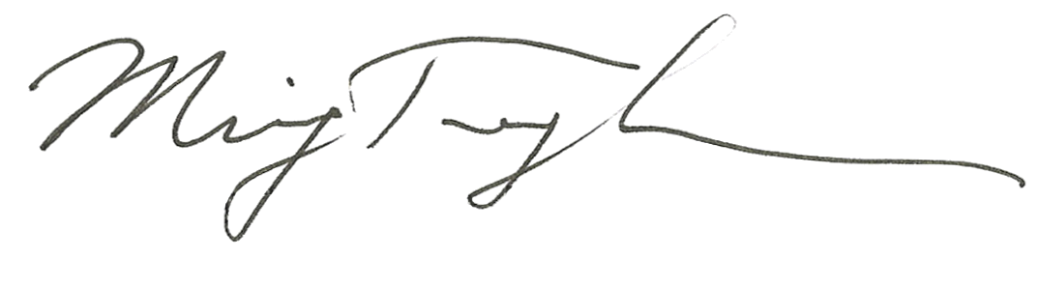
二埠印支華裔聯誼會

For Information Contact:
CNYCA
P.O. Box 163690
Sacramento, CA 95816
Phone: (916) 392-8026
Chinese New Year Culture Association
www.CNYCAsacramento.org
華人新春聯歡會
Chinese New Year Celebration

Event Date: February 19, 2005
Place: California State University, Sacramento, and University Union

August 31, 2004

Dear Business Leaders and Friends:
Please accept our invitation to participate and support the Year-of-the-Rooster Chinese New Year Celebration taking place on February 19, 2005 at the CSUS University Union.
Attached are a flyer and a sponsorship form for this cultural celebration event. The Chinese New Year Culture Association (CNYCA) and California State University at Sacramento (CSUS) are jointly sponsoring this event.
The CNYCA is formed by many local Sacramento area Chinese American organizations. One of its primary objectives is to promote the Chinese culture and heritage through the celebrating of Chinese New Year event. This will be the eighth Chinese New Year Celebration event. The past several events, each with over three thousand participants, have proven to be very successful in bringing the community together and promoting the rich Chinese Cultures. This year’s celebration will include traditional lion dances, martial arts, Chinese painting and art exhibits, music and ethnic dancing performances, singing contest, children’s games and other cultural activities. US Post Office will also unveil the Chinese Zodiac Stamp during the event. Many local businesses are taking this opportunity to market their goods and services to the public by setting up vendor booths during the event.
We would greatly appreciate the support and participation by your business or organization. You can participate and support this event by being an event sponsor, vendor, or by placing ads in the event program book. Please review the attached sponsorship form and flyer, and inform us of your sponsorship decision. If you have any question regarding this event; please contact me, or any of the Committee members listed on the flyer.
Thank you for your support and generosity.

Sincerely,

Ming-Tung “Mike” Lee, Ph. D.
Chair of CNYCA 2005 Committee

Attachments: Sponsorship Form and Flyer

